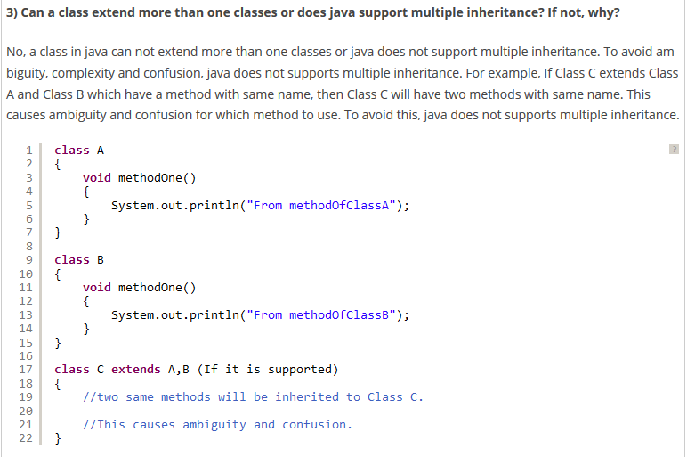



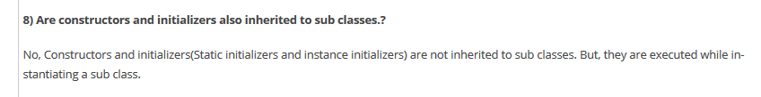

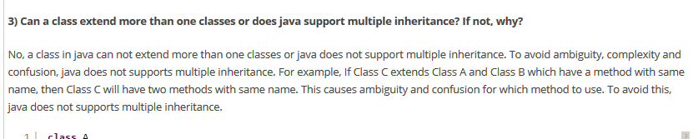

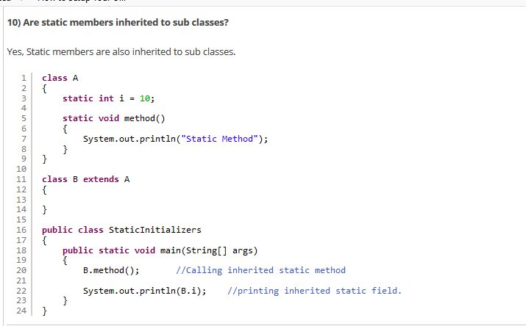

**Points-To-Remember About Inheritance In Java :**

Here are some points regarding inheritance in java.

* Constructors, SIB – Static Initialization Block and IIB – Instance Initialization Block of super class will not be inheriting to its sub class. But they are executed while creating an object to sub class. For example,

## ****Effect of private, default, protected and public keyword on inheritance in java:****

**private :** Private members can not be inherited to sub class.

**Default** : Default members can be inherited to sub class within package.

**protected** : protected members can be inherited to any sub class but usage of protected member is limited within package.

**public** : public members are inherited to all sub classes.

